A Brief on What Makes the Mainstream Media Conservative

When “Muckraking” first earned its name many journalists considered themselves to be of the working class and some wrote by the motto that “journalism should afflict the comfortable and comfort the afflicted.” But long gone are those days in this age of media concentration and corporate domination. Powerful people and institutions have strong self-interested reasons to resist the media’s inspection and the public accountability it can inspire. And so the issues are framed, topics selected, debate bounded, concerns distributed, emphasis emphasized, and information filtered in order to serve the interest of dominant elite groups. The following is brief on the strong and pervasive forces that give the mainstream media an obvious pro-establishment bias.

The 5 Major Herman and Chomsky Filters of the Propaganda Model
Partially lifted form a Znet (www.zmag.org) interview with Edward Herman

1. Ownership: Very wealthy people and corporations, like General Electric, own and control the dominant media and give it an elite bias. By elite we mean power elite: very wealthy and connected people. The dominant media is an increasingly concentrated and therefore powerful and unaccountable group. As of 2002 the U.S. media system was dominated by about 10 transnational conglomerates including: Disney, AOL Time Warner, News Corporation, Viacom, Vivendi Universal, Sony, Liberty, Bertelsman, AT+T Comcast, and General Electric. Another 12 to 15 firms like Gannett, Tribune Company, Hearst, Westinghouse, and Clear Channel complete the entire national media system. Ownership has the obvious effect of turning news into a product to be manufactured and sold. Media, being and industry has to keep its costs low to maximize profits. Corporate conglomerates increasingly view journalism as “software,” standardized and valuable only insofar as it contributes to the bottom line regardless of how degraded the news becomes. This concentration of ownership censors critical political opinion and perspective (The Dixie Chicks are Terrorists you know) and outright broadcasts propaganda for powerful interests such as the Pro-War Rallies that were organized and mobilized by Clear Channel DJs. Concentrated ownership cuts out local control and ideas and it homogenizes what is news limiting diversity and killing creativity.
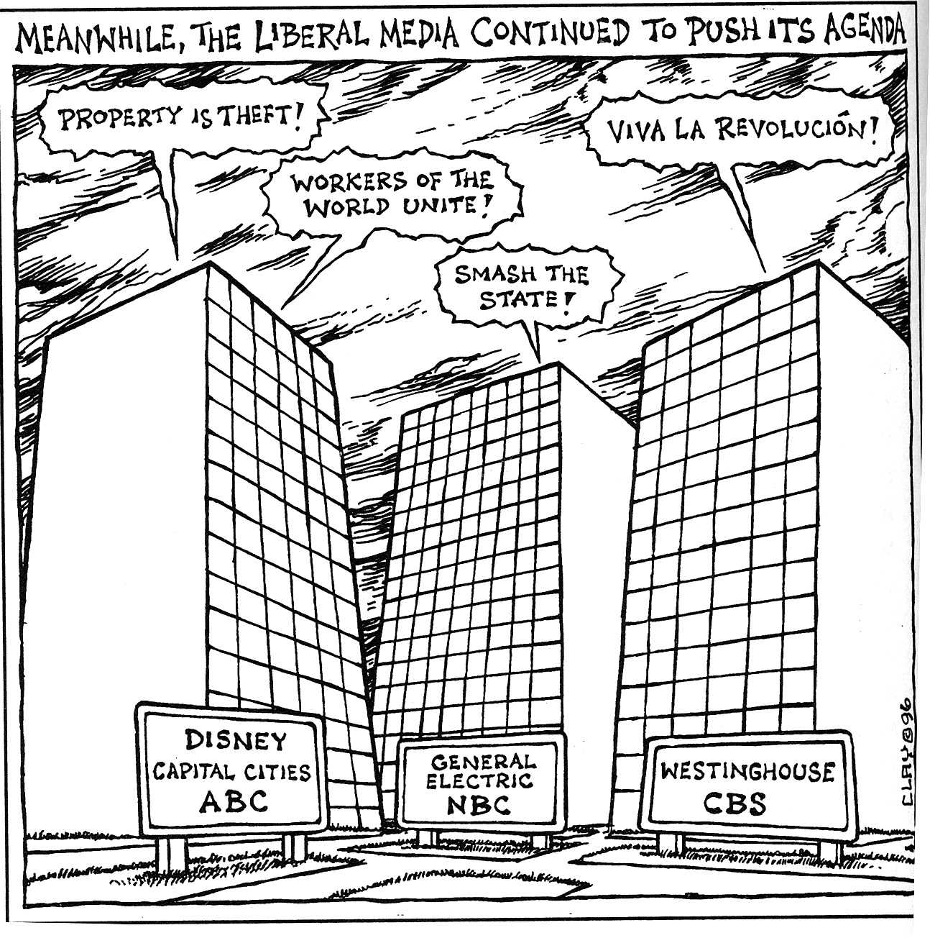
2. Advertising: If the paper didn’t already have written or unwritten political boundaries or an outright political agenda the fact that dominant media corporations are dependant on advertising from other dominant corporations brings the media in-line to a pro-corporate plutocratic agenda. For instance, Proctor and Gamble has written rules for advertising. It will not support programs that insult the military or “suggests that the business community is not a good and spiritual community.” Besides distorting markets and the concept of supply and demand, saturating everything with unquestionable pro-corporate propaganda, brainwashing children, and being constantly in our faces, it is advertising that turns citizens into consumers. We make decisions by buying what is presented to us, not by directly and democratically participating in decision making. It is Coke or Pepsi, George Bush or Al Gore. (Regarding the last example it also reduces political debate to 30 second spots based on based on perception of personality.)
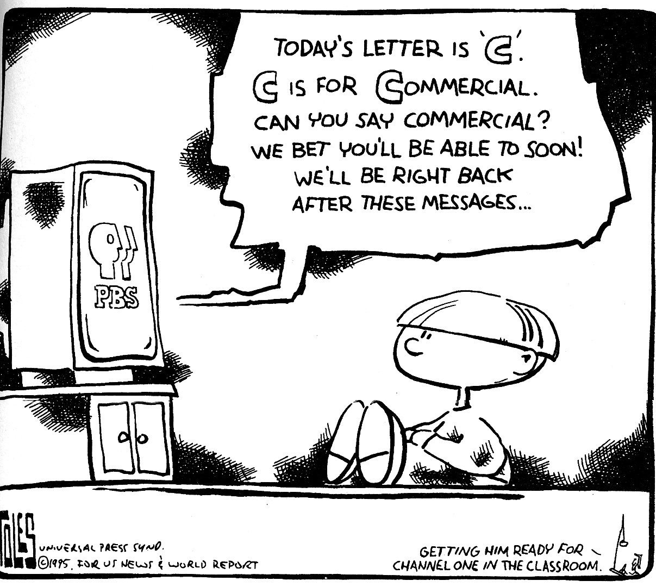
3. Status Quo Sources: Journalism is expensive so it is important to get cheep sources that are perceived to be legitimate such as the White House, the Pentagon, General Motors, the police department. These are the decision and news makers and their is a strong tendency to get close to sources that are powerful. Those in the media adopt relationships with these powerful institutions and adopt their psychology printing stories that further legitimate their perceived authority. It costs money to find detractors who will criticize power or call high officials liars, not to mention that this type of activity will alienate the cheep sources that media is dependant on for its product.
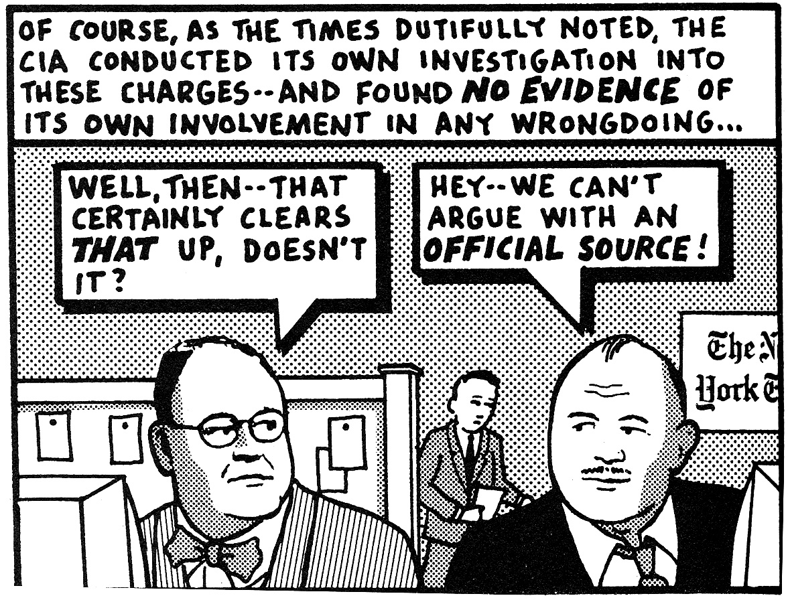
4. Flak: Flak is negative feedback released to negate or redirect criticism. Everyone can produce flak by writing angry letters but it is the negative feedback from powerful groups: the Pentagon, big advertisers, and other organized groups that can seriously threaten and redirect media’s criticism or focus.

5. Ideology: For instance: an Ideology constituted by the power elite that has come to be inherent in the American media is anti-communism. Communism has been made out to be the Soviet Union and the Murderous tyranny of Stalin and any systematic economic criticism from the left is simply shouted down as communist. Anything that threatens what the power elite call capitalism or the “Free market” falls into this category. In terms of economic viewpoints from the left the best you’ll see is an angry post-Keynesian intellectual in the middle of an Enron scandal. BUT NO FURTHER! Unions, Collectives, or other forms of worker lead participatory economics are rarely covered or portrayed as impossible, costly or troublesome.

The Myth of the Liberal Media: This is related to flak, but it is the all-encompassing flak that forces the entire media to the right. Rich Bond, Chairman of the Republican Party in 1992 calls crying liberal media “working the refs.” But it is easily demonstrated that they own the refs, what they are working is the audience’s ignorance. “In a careful 1999 study published in the academic journal Communications Research, four scholars examined the use of the ‘liberal media’ argument and discovered a fourfold increase in the number of Americans telling pollsters that they discerned a liberal bias in their news. But a review of the media’s actual ideological content, collected and coded over a 12 year period, offered no corroboration whatever for this view. The obvious conclusion: News consumers were responding to ‘increasing news coverage of liberal bias media claims, which have been increasingly emanating from Republican Party candidates and officials.’”
This negative feedback has the force of inertia in framing the very idea of bias in the media today making the most obvious criticism open to the claim of subversion. Paul Krugman puts it this way, “The next time the administration insists that chocolate is vanilla, much of the media - fearing the accusations of liberal bias, trying to create the appearance of ‘balance’ - won’t report that the stuff is actually brown; at best they’ll report that some Democrats claim it’s brown.” The media is not conservative, it’s liberal! Yeah! (And ignorance is strength)

Concision: Television is a very dominant source of news for most people in this country and making the point within the framework of television is an important aspect of delivering a message. Jeff Greenfield of NIGHTLINE openly states “We need concision.”
The beauty of concision, saying a couple of sentences between two commercials or even 600 words in an editorial, is that you can only repeat conventional thoughts. If you say something that is the least bit unexpected or controversial you are going to need a lot of evidence and discussion to back it up and concision won’t allow it. Short jolting statements often work best, but simplicity often relates to a lack of information, context or background. Though understanding is more difficult than irrational fear and history is more complex than heroification. The United States is ideologically much narrower in general than other countries and further more this aspect of concision within the structure of American media is such as to pretty much eliminate critical discussion.
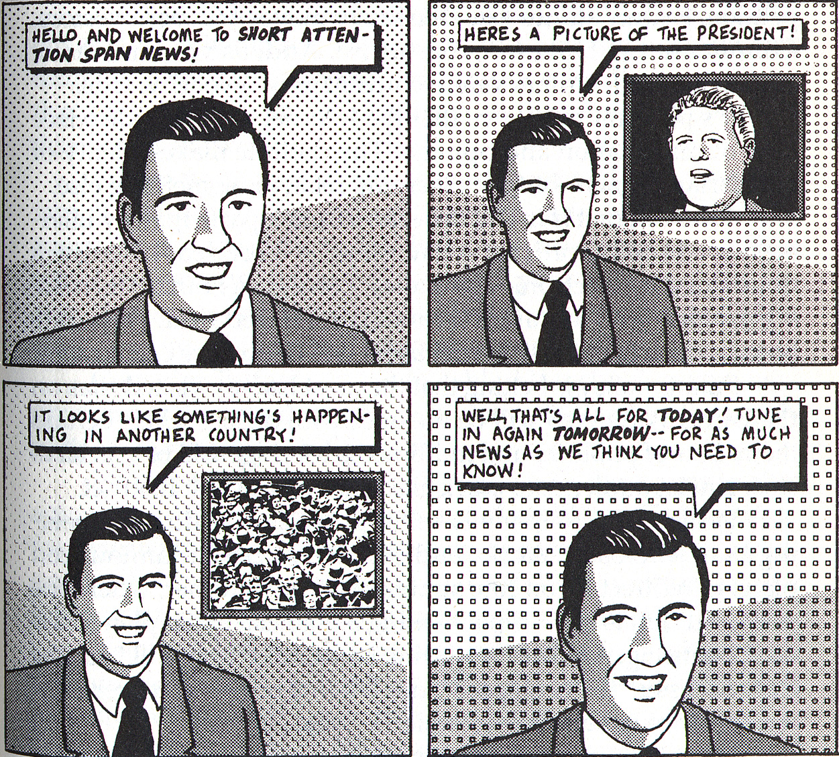
The Guise of Objectivity: When we pick up the paper many of think we are getting what is news. This is the story and we depend on it for our knowledge, but almost all of us have been socialized to accept a range of debate, sources, and functions of different institutions in society. The power of inertia tends to perpetuate existing ways of doing things and existing relationships. The point is that objectivity is impossible to achieve and to limit an issue to both sides is to define those sides and denies that the larger an issue the more dementions it has.

Propaganda is actively used: Gore Vidal once said that “It is the role of the politician not to give up the game.” What he meant is that politics is largely a sideshow presented to us to smile and entertain. They may offer slight adjustments, tinker, or even try to introduce debate but they are resting on the true source of power which is social conventions and the process of production. So in their role, when problems arise politicians have responded by presenting targets for the anger and frustration of working people and much of the middle class. We have been told that poor people are the reason for hard times, ripping us off and draining us dry through welfare. We have been told that foreign workers are willing to work cheep in order to take our jobs away. We are presented with images of black criminals with ominous music, and we hear that taxes are the cause of our predicament.
But it is more formal than politicians creating scapegoats, It is a huge public relations industry that leaks propaganda articles employs journalists and censors debate to create benevolent perceptions of power. Chomsky gives us some history, “This huge public relations industry, which is a U.S. invention and a monstrous industry, came out of the first World War. The leading figures were people in the Creel Commission. In fact, the main one, Edward Bernays, comes right out of the Creel Commission. He has a book that came out right afterwards called Propaganda. The propaganda system of the first World War and this commission that he was part of showed, he says, it is possible to "regiment the public mind every bit as much as an army regiments their bodies." By manufacturing consent, you can overcome the fact that formally a lot of people have the right to vote. We can make it irrelevant because we can manufacture consent and make sure that their choices and attitudes will be structured in such a way that they will always do what we tell them, even if they have a formal way to participate.”

