The Badger Herald is a Right Wing Newspaper
“Editorial pages will give some attention to what are sometimes considered “Conservative” approaches to attacking the many severe problems that attack society.” (9/10/69)
With this introduction, from the Badger Herald’s first issue its career began as a campus newspaper that would seek to advance the agenda of the right on campus. It’s main purpose is to move the entire discourse on campus closer to its own right-wing stance. It was founded by four white men in 1969 to support the Vietnam War and serve as a countervailing force to the overwhelming anti-war sentiment on the campus. According to its own history posted on its own website, The Herald was close to going out of business in 1971, the height of student activism on campus. To survive, it held a fundraiser attended by conservative celebrity William F. Buckley III. The Herald has grown considerably through the conservative 80s and 90s surpassing the Cardinal in color, flashiness and circulation.

The Herald is a proud disseminator of the status quo. It serves the most concentrated forms of power at every level of society from the State Street Business Association to the Board of Regents to the Republican Legislature all the way to the White House.
It is constantly running stories, comics and ads to perform this function.
Some classic examples include:
Nov. 1993 BH publishes an extended three part
interview with KKK Grand Wizard, Tom Robb, and does
not bother offering any equivalent counterpoint

Sept. 1998 BH prints another offensive cartoon in
which two male characters "joke" about grabbing a
woman by the wrists and ankles and raping her
Feb. 2001 BH prints a full page advertisement from
neoconservative, David Horowitz, titled "Ten Reasons
Why Reparations For Slavery is a Bad Idea,"
prompting another protest of about 150 students
organized by the Multicultural Student Coalition
It often runs ads that are funded by right-wing organizations and think tanks and this has become a significant issue. Last year, after publishing an ad from campustruth.org that showed a candlelight vigil in Israel for September 11th victims and a pre9-11 picture of Palestinians dancing in the streets firing guns the Herald was forced to put a disclaimer above the ad and allow Al-aweda to print a weekly column stating the Palestinian perspective.
How else does the Herald Manifest its ideology?
Some giveaways:
- It is constantly running articles talking about the liberal slant of your professors. Beware, Professor Friedman voted for Al Gore!!
- Once in a while you will see coded articles about how the university is inefficient and needs to privatize.
- It’s national insert comes from the Wall Street Journal. Enough said.
- Many of the leftists it hires are put to work on the Arts page. Sorry, but a review of the new Radiohead Album doesn’t force me to consider the power dynamics of society.
- The Sports Page is an unmatched opiate in terms of size and flash.
- Considering the attention it gives them, DRINK SPECIALS ARE THE MOST IMPORTANT ISSUE IN THE WORLD!!!
- The Digest Page (page two) almost without interruption, ran lead headlines that were basically advertisements for the Bush Administration.
- Regarding issues such as war, labor, affirmative action, a clear bias exists as you read through many articles. Take for instance that issue of tuition. Where do you think the Herald falls on this issue that is of utmost importance to its primary constituency? Well, to put it nicely, the Herald is often apologetic of tuition hikes. It likes to think that No matter how much faster it increases than inflation it is called a “bargain” in articles and editorials. A stat is often displayed that compares us to other Big 10 universities. Yeah, sure our tuition is going up $700 but we still don’t have to pay as mush as Ohio State! It is fond of quoting administrators like Vice Chancellor Darrel Bazzel saying things like: “In-state tuition is still below the mean for our peer group (of schools).” Its tactic is to avoid a discussion of the direct and obvious effect which is that we are paying $700 more to go to school this year and places it in the context that relates it to other schools tuitions which are also spiraling out of control. In doing so it avoids the broader and more serious issue of post-secondary education swiftly becoming an exclusively elitist pursuit and more effective segregating mechanism as it prices working class students out of this essential tool. What a bargain!!

- Its news reporters are interchangeable with its very partisan editorial staff. For instance, before Herald Columnist Eric Cullen was spewing in his weekly opinion column he was on the Herald’s news staff covering campus events. This year he runs the paper! Last year arch-conservative and Tom Delay’s favorite laky, Matt Modell, featured jaw dropping entertainment on the editorial page; “Protestors Resist Their Americanism” 3/6/03, “It’s Time to Let Freedom Ring” 4/10/03, Women’s Studies Lecturer Off the Mark” 4/17/03 this summer covering the state budget as the state politics reporter and tried to tell us that Republicans feel the campus’ pain. This semester he will be the Editorial editor.
- One of its biggest tools is slanted headlines. These are often used to demonize leftist action as negative, abrasive, or directionless. It often deflates numbers and emphasizes downsides. Don’t bother standing up for your rights or protesting corruption and oppression, those people don’t know what they are talking about. Stay stupid, aloof, and apathetic. The world is fine and it is futile to change it. Just check out the following:
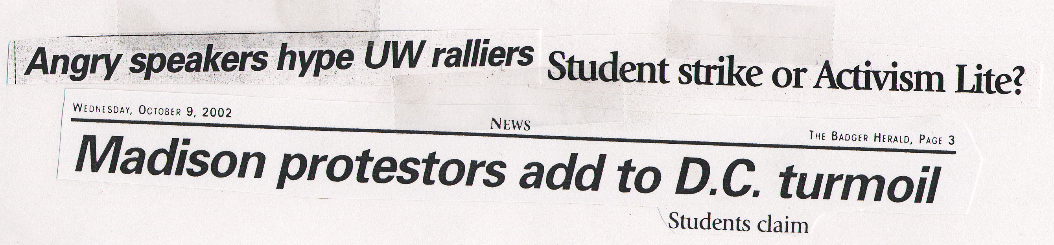
The most obvious aspect of the Herald’s pro-establishment bias is on it’s editorial page.
A variety of writers love using the line that Madison is an island or “72 square miles surrounded by reality.” in order to dismiss action. Then there are the columns that test anything outside the order. Some of these crazy editorials include “Passing on the Bus Pass,” an editorial against bicyclists that said “I was thrilled to see a cop and very grateful to him for scolding the biker who nearly ran me over.” and one that bashed TV Turn-off Week where the weekly columnist proudly stated how see was going to “veg-out to Dawson’s Creek.” It is almost as if they sit around asking how can we extend the dominance of mainstream televised propaganda, the internal combustion engine, sprawl, and anything outside the commercialized hegemony.
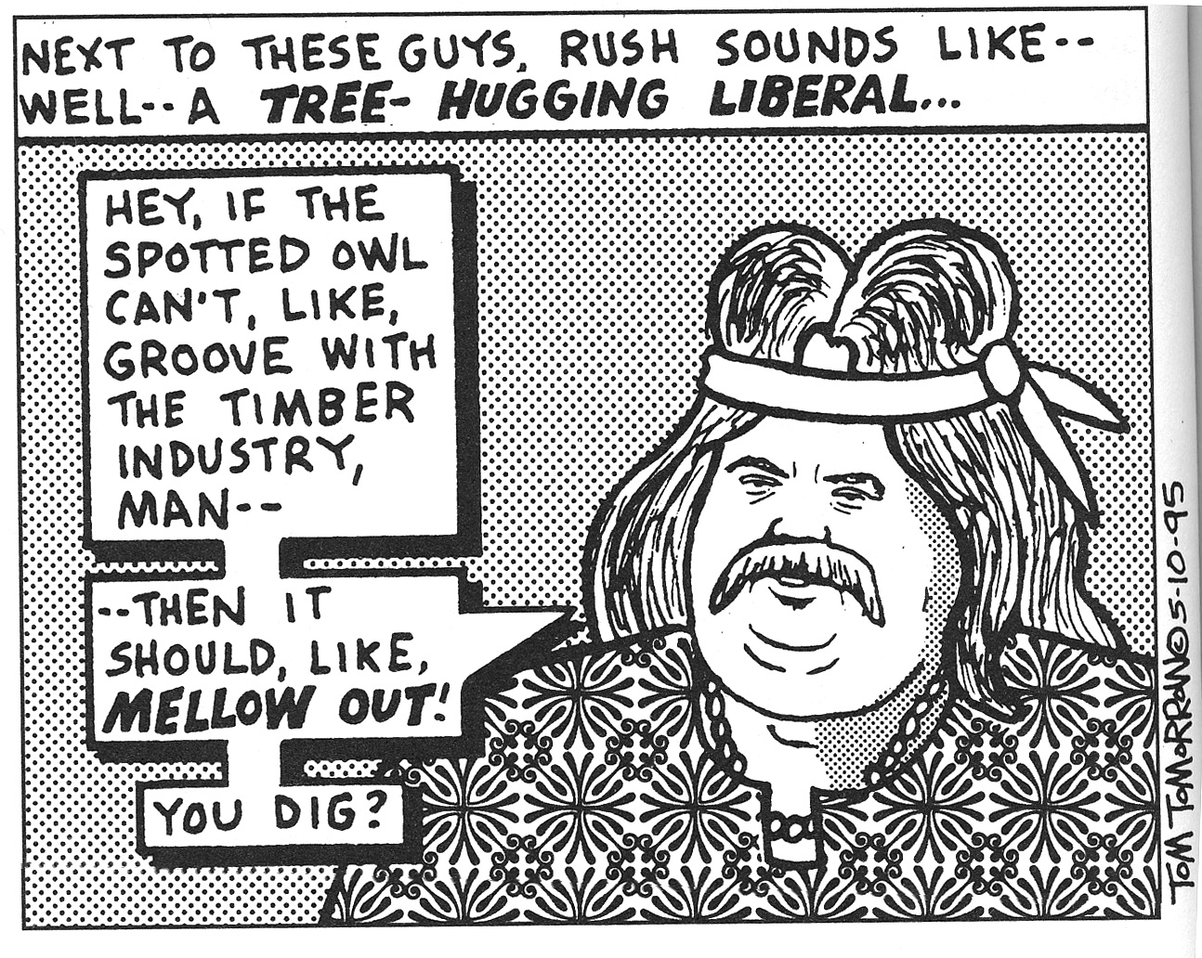
It isn’t blanket conservativism. Even the most apolitical freshman would be able to pick that up. It features a token liberal from time to time. It is sort of like Hannity and Combs except there is five Hannitys and the Combs is uglier than he is on TV. This year Josh Orton will be going up against Nicole Marklein, Mac VerStandig, and basically the rest of the staff. The slant is easily documented.
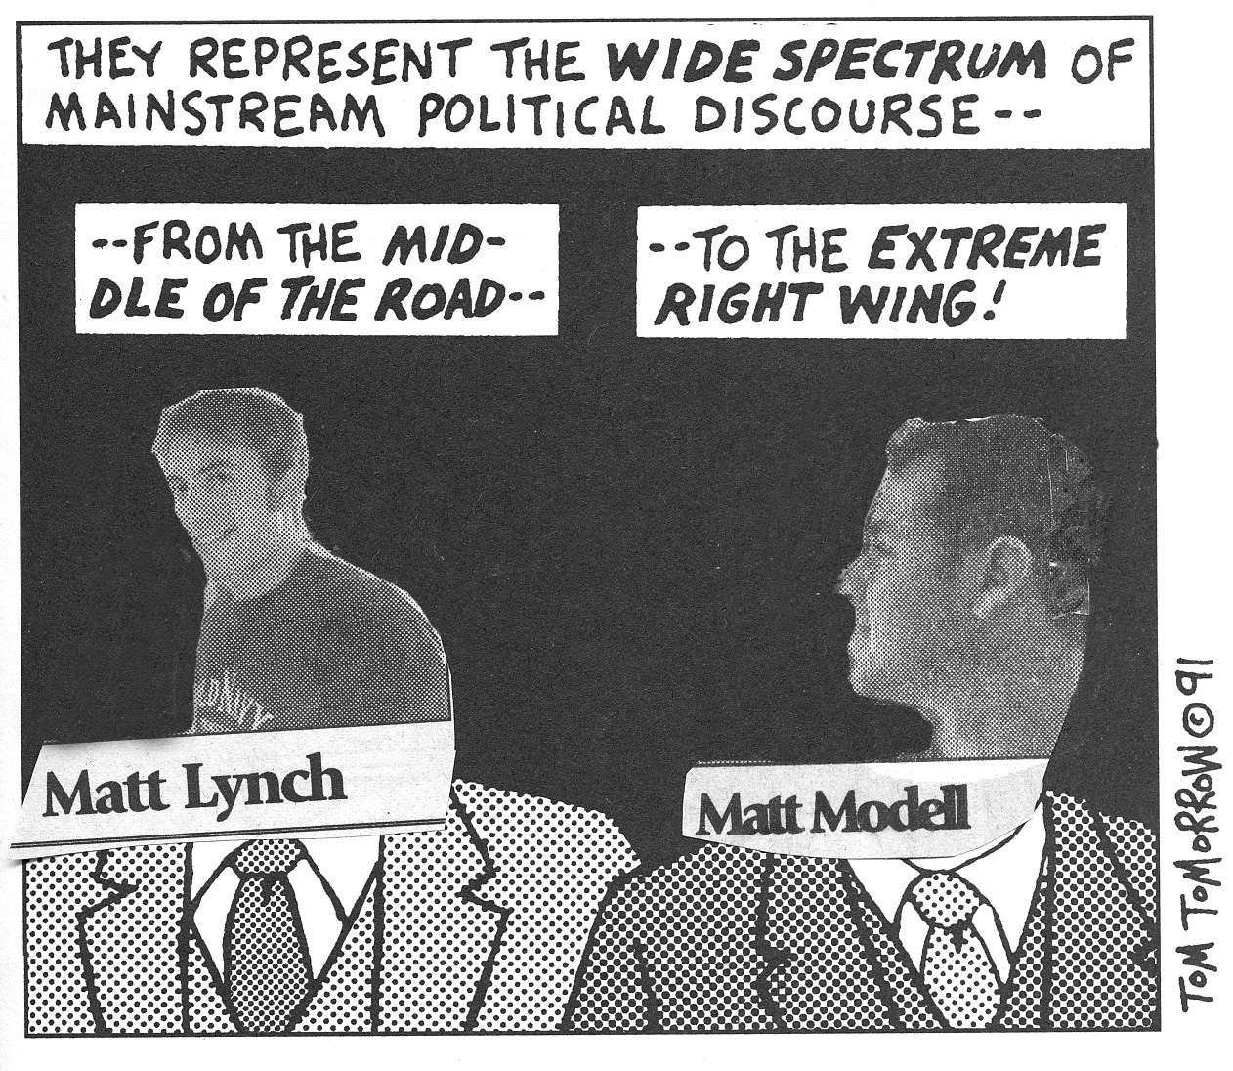

We took last year’s papers from August 30th through Oct 10th at random and found the following results. MODERATE = an observation of both sides and no claims. FLUFF is when they use print to write about things like the football games. The LEFT broadens power to otherwise disempowered or unorganized groups or works to build political power for their issues. And RIGHT means that the article served to concentrate power.

