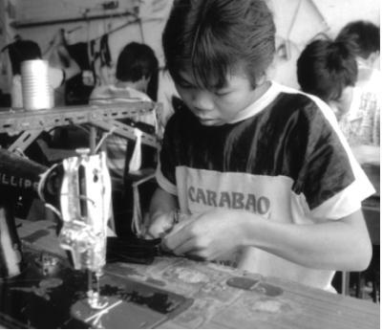
UW CLOTHES ARE MADE
IN SWEATSHOPS!
…BUTWE CAN CHANGE THAT.

UW hoodies, jerseys, hats, and sweatpants are made in factories with conditions like these:

o humiliating “medical examinations” El Progresso, Honduras: A factory that produces UW t-shirts repeatedly subjected women workers to humiliating "medical examinations". During these genital groping sessions, company doctors forced workers to disrobe and then made lewd facial gestures and sexually charged comments.

o 21 cents an hour Guangdong, China: In a UW hat factory, workers make 21 cents an hour. This includes overtime pay.

o sew for 24 straight hours Cakung, North Jakarta, Indonesia: A sweatshop that produces for Eddie Bauer, Timberland, and Liz Claiborne forced workers to sew for 24 straight hours. The next day, they were fired and the factory moved overseas.

o musculo-skeletal disorders Derby, New York, United States: In 2001, 46% of workers were diagnosed with musculo-skeletal disorders while producing New Era caps for UW. 88% of workers reported chronic on-the-job pain.

o 1000 workers fired for starting a union Cakung, North Jakarta, Indonesia: An Adidas and VF Sportswear factory that produced backpacks for UW “cut and run” after workers organized and demanded better working conditions. Over 1000 workers lost their jobs.

o 23 workers died Narayanganj, Bangladesh: This January, workers were locked into the Sun Knitting and Processing garment factory. A fire tore through the building and 23 workers died. Many more were injured or disfigured.

STAND UP! SPEAK OUT!
The UW community demands that the administration take the strongest possible stance against sweatshop labor: UNION NOW!
For more information or to get involved:

Student Labor Action Coalition
Thursdays, 7:00 pm TITU
slac.rso.wisc.edu

